**NNSFv1.01TW Installation Instructions & Manual**

After downloading the file you got these files:

1. **Extract NNSF v1.01TW.zip -**You are to extract the file or open them with explorer (if you are in windows) because this is a compressed file. You can find this file in your Download folder in your computer.

To Extract:

* Right click the file and you can see this:  
  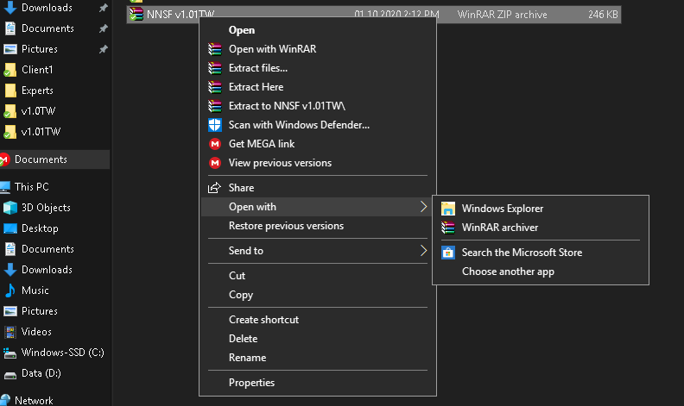

Select “Extract files” or you can select “Open with” > Windows Explorer

You will see this:

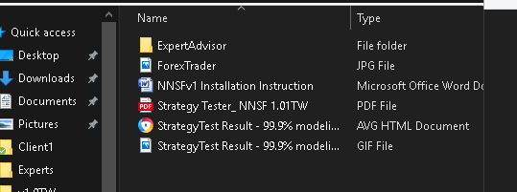

* Double Click the ExpertAdvisor folder and you will see these files  
  1. NNSF 1.01.ex4  
  2. NNSF1.01TW.set  
  Copy these two files and save it in a temporary folder location (Desktop may be ideal).

1. **Open your MetaTrader 4 Platform**

* Go to File Pull Down Menu and select “Open Data Folder”
* Double click the MQL4 folder – you are now at MetaTraders\MQL4 folder
* Double click Experts folder
* Go back to the folder where you copied the two(2) files earlier in step #1
* Copy the NNSF 1.01.ex4 and paste it to Experts folder and then close the folder window.

1. **Go back to your MetaTrader 4 platform**

* Go to the Navigator and right click on the Expert Advisors then select Refresh.
* You can now see the EA listed among them
* Open your EUR/USD Chart and attach the EA (Click and Drag will do)  
  This EA has been tested with EUR/USD pair although this EA will work** with any 5-Digit pair.  
  ** *Make sure you are going to optimize the settings in other pair. Do not use the set file with other currency pair.*
* This Dialog will Pop-up  
  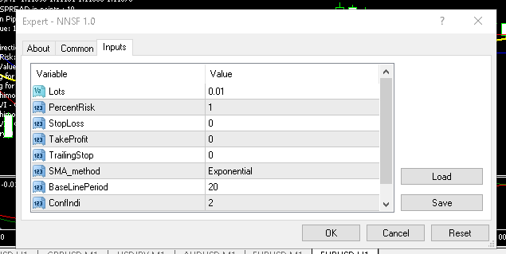
* Click Load and navigate to the location of the Set file (NNSF1.01TW.set) by selecting it. Then you got this.  
  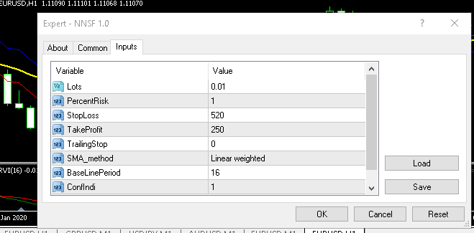
* Then Click OK button. DONE

1. Make sure that AutoTrading is enabled (you got a smiley face after the name of your EA on the Right side of the chart)

ABOUT THE INPUT PARAMETERS / Settings

* Lots – of course the Lot size of every trade to make
* StopLoss – Number of points where the trade stops if it is a loosing trade
* TakeProfit – Number of points where the EA takes profit.
* TrailingStop – Number of points to trail stops.
* SMA_method – you got 4 options

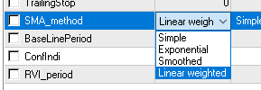

* BaseLinePeriod – Moving average period of the baseline.
* ConfIndi – Confirmatory indicator to be used by the EA (2 options)

1. RVI
2. Ichimoku

* RVI Period – RVI indicator period.

`